1. **Identifikasi dan Kebutuhan Teknis Perancangan Jaringan**

Kasus :

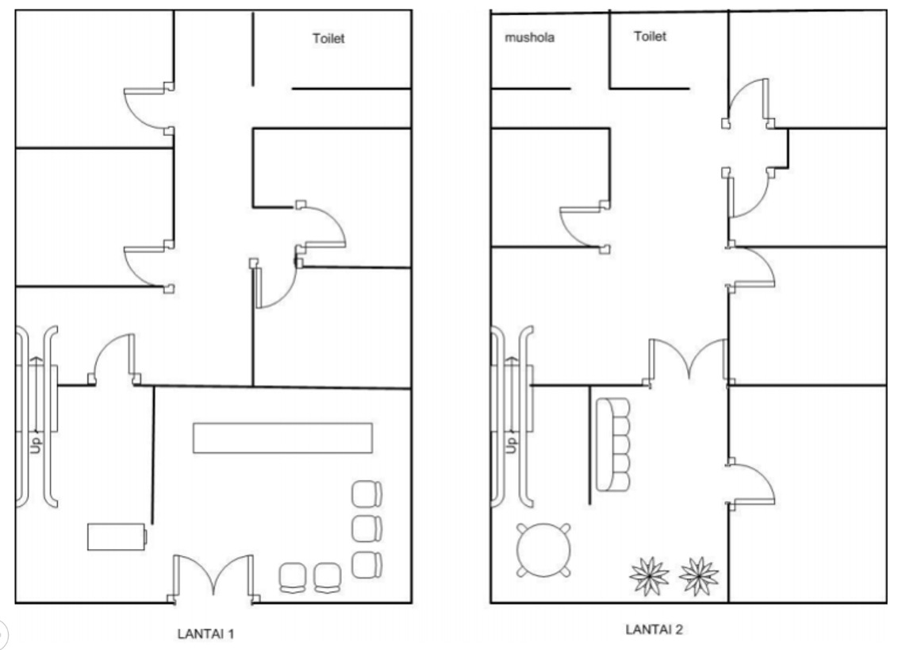

AP

AP

AP

AP

R 2.6

R 2.5

R 2.4

R 2.3

R 1.2

R 2.2

R 2.1

R 1.4

R 1.5

R 1.3

R 1.1

1. **Uraian Hasil Survey Lapangan**

|  |  |  |  |
| --- | --- | --- | --- |
| **Ruang** | **Perangkat** | **Qty** | **Ket:**  R = Ruangan  L = Lobby  1.xxx = Lantai 1  2.xxx = Lantai 2 |
| R 1.1 | PC | 2 |
| AP | 1 |
| R 1.2 | PC | 10 |
| R 1.3 | PC | 10 |
| R 1.4 | PC | 10 |
| R 1.5 | PC | 5 |
| L 1.1 | AP | 1 |
| R 2.1 | - | - |
| R 2.2 | PC | 4 |
| AP | 1 |
| R 2.3 | PC | 10 |
| R 2.4 | PC | 4 |
| R 2.5 | PC | 5 |
| R 2.6 | PC | 5 |
|  | | | |
| **Total Perangkat** | **Lantai 1** | **PC 37 / AP 2** | |
| **Total Perangkat** | **Lantai 2** | **PC 28 / AP 2** | |
| **Total Keseluruhan** | **PC 65 / AP 4** | | |

1. **Identifikasi Kebutuhan**

|  |  |
| --- | --- |
| **Identifikasi Kebutuhan** | **Hasil Identifikasi Kebutuhan** |
| Jenis layanan | LAN, internet, database, wireless, web, email |
| Skalabilitas | Kecil, jumlah < 70 orang (65 PC)  Workstation <70, wireless <60 |
| Ekspandibilitas | Ya (penambahan ruang, Gedung, pengguna) |
| Lokasi | Satu lokasi, dalam 1 gedung, 2 lantai |
| Media transmisi | Kabel dan wireless |
| Besar bandwith | Internet <= 70 Mbps  (Dengan asumsi setiap user mengguanakan <= 1 Mbps) |
| Ketersediaan perangkat keras | Workstation, Laptop, Smartphone |
| Manajemen dan monitoring system | Belum ada |
| Keamanan | Firewall |
| Alokasi biaya | Tersedia |
| SDM | Operator (1 Orang), Teknisi IT (2 Orang) |

1. **Skema**



**5 PC**

**10 PC**

**10 PC**

**10 PC**

R 1.2

R 1.3

**2 PC**

**5 PC**

**5 PC**

**4 PC**

**10 PC**

**4 PC**

R 1.1

R 2.6

R 2.5

R 2.4

R 2.3

R 2.2

R 2.1

R 1.5

R 1.4

|  |  |  |
| --- | --- | --- |
| **Icon** | **Hardware** | **Total** |
|  | PC | 65 |
|  | AP (Acess Point) | 4 |
|  | Router + PC Server | 1 |
|  | Switch | 10 |
|  | Internet |  |
|  | Kabel UTP |  |
|  | FO Provider Kabel |  |

1. **Anaslisa Kebutuhan Perangkat**

|  |  |  |  |  |
| --- | --- | --- | --- | --- |
| **NO.** | **HARDWARE** | **Qty** | **SPESIFIKASI** | **KETERANGAN** |
| 1 | Koneksi ke ISP | 1 | Kecepatan <= 70 Mbps | Biznet, Dedicated |
| 2 | Router | 1 |  | Setup DHCP, NAT, firewall |
| 3 | Computer Server | 1 |  | Database server |
| 4 | Computer Client | 65 |  | Standard Office PC |
| 5 | Switch | 10 |  | R 1.2,1.3,1.4, 2.3 = Switch 16 Port  R 1.1,1.5,2.2,2.4,2.5,2.6 = Switch 8 Port |
| 6 | Access point | 4 |  | AP Pada Lobby Lantai 1 dan Lorong Laintai 1  AP Pada Lobby Lantai 2 dan Lorong Laintai 2 |
| 7 | Kabel UTP | 2 | Rol @100m | Instalasi kabeling |

1. **Spesifikasi Hardware Perangkat**

|  |  |  |  |  |
| --- | --- | --- | --- | --- |
| **Unit** | **Requirment** | **Specification** | **Price** | **User** |
| 1 | Computer Server (3) | * Processor Vendor : IntelGenuine * Processor Name : Core i7 8700 BOX 3.2Ghz (Socket 1151 Coffee Lake) * Processor Speed : 4.60 GHz * Processor Cache size : 12 MB * Motherboard : Msi B360m Pro-Vdh * Memory : Ram DDR4 8gb X 2 * Harddrive : SSD 240 GB + HDD 500 GB | 15.500.000 | - Operator IT  - Teknisi IT |
| 65 | Computer Client | * Processor Vendor :IntelGenuine * Processor Name : Intel Core i5-650 (3.2GHz, C4Mb) * Motherboard : Cipset Intel H55 Amptron/MAGIX * VGA Card : Onboard Intel HD * Memory : DDR3 8gb * Harddrive : 500gb Seagate Sata * Drive Storage : Samsung DVD Drive * Sound Card : Onboard * Casing : Power Up / Optimax Seri Random * Monitor : LED LG 19" * Keyboard Mouse : Logitec Optical Media | 3.500.000 | Office Staff |
| 1 | Router (2) | * **Mikrotik 10 Gigabit Port Router Rb4011igs+Rm** * Serial port : RJ45 * PoE in : Passive PoE * PoE out : Passive PoE up to 57V * PoE in input Voltage : 18-57 V * Number of DC inputs : 2 (PoE-IN, DC jack) * DC jack input Voltage : 12-57 V * Max out per port output (input > 30 V) : 400 mA * Max out per port output (input < 30 V) : 600 mA * Max total out (A) : 600 mA * Max power consumption : 33 W * Max power consumption without attachments : 18 W * Antarmuka / Interface * 10x 10/100/1000 Ethernet ports * 1x SFP+ ports * Fitur * CPU : AL21400 * CPU core count : 4 * CPU nominal frequency : 1400 MHz * Architecture : ARM 32bit * License level : 5 * Operating System : RouterOS * Size of RAM : 1 GB * Storage size : 512 MB * Storage type : NAND * Dimensi Produk * 228 x 120 x 30 mm | 5.500.000 |  |
| * **CISCO RV345 Dual WAN Gigabit VPN Router [RV345-K9-G5]** * Operating Frequency * 2.4 GHz * 5 GHz * Lain-lain * Firewall : Stateful packet inspection, up to 980 Mbps throughput for TCP and UDP * Quality of Service (QoS) : Traffic Classes, WAN Queuing, WAN Policing, WAN Bandwidth Management, Assign detailed QoS (Class of Service (CoS)/Differentiated Services Code Point (DSCP)/policies) settings per application or end device * Web Security : Dynamic web filtering: Cloud based, more than 80 categories, more than 450 million domains classified * Application Visibility : Application identification: Assign policies to Internet applications 500 unique Apps * Antarmuka / Interface * WAN ports : 2 RJ-45 Gigabit Ethernet * 16x RJ-45 Gigabit Ethernet * Console/serial : 1 RJ-45 port for future use. Port is disabled * USB : 2 for external 3G/4G modem or flash drive (USB-3, USB-2) * Kelengkapan Paket * SNTC-8X5XNBD Cisco RV345 Dual WAN Gigabit VPN Route (1 years) CON-SNT-RV345K9G * Standards Protocol * IEEE 802.11ac * 802.11n * 802.11g * 802.11b * 802.11a, 802.1X (security authentication) * 802.1Q (VLAN) * 802.11i (WPA2 security) * 802.11e (wireless QoS) * Fitur * PU ARM-based architecture, dual core, hardware flow engine 900 Mhz * RAM 1 GB DDR3 * Flash 256 MB * Antenna gain in dBi : 2.4 GHz: 3 dBi each antenna; 5 GHz: 5 dBi each antenna * Dimensi Produk * 280 x 44 x 170 mm | 8.500.000 |  |
| 4  6 | Switch (5)   * 16 Port * 8 Port | * **16 Port** TP-LINK TL-SF1016D * Switching features * Mac Address Table 1K * Power Supply * 100~240VAC, 50/60Hz * Ports * 16 x 10/100Mbps RJ45 Ports AUTO Negotiation/AUTO MDI/MDIX * Kelengkapan Paket * 16-Port 10/10Mbps Desktop Switch TL-SF1016D * Power Adapter * User Guide * Dimensi Produk * Dimensi Unit : 200 x 142 x 40 mm (WxHxD) * Others * Fan Quantity : Fanless * Power Consumption : Maximum: 3.1W (220V/50Hz) * Transfer Method : Store and Forward * Advanced Functions : Green Technology, saving power up to 80% 802.3X Flow Control, Back Pressure * Certification : FCC, CE, RoHs * System Requirements : Microsoft® Windows® 98SE, NT, 2000, XP, Vista™ or Windows 7, MAC® OS, NetWare®, UNIX® or Linux * Environment : Operating Temperature: * 0℃~40℃ (32℉~104℉); Storage Temperature: -40℃~70℃ (-40℉~158℉); Operating Humidity: 10%~90% non-condensing; Storage Humidity: 5%~90% non-condensing * Media interface * RJ45 | 500.000 |  |
| * **8 Port** TP-LINK TL-SF1008D * Switching features * Buffer Size 2Mb * Data Rates : 10/100Mbps at Half Duplex ; 20/200Mbps at Full Duplex * Power Supply * 100-240VAC, 50/60Hz * Ports * 8 x 10/100Mbps Ports, Auto-Negotiation, Auto-MDI/MDIX * Kelengkapan Paket * 8-Port 10/100Mbps Desktop Switch * Power Adapter * Dimensi Produk * Dimensi Unit : 13.5 x 7.9 x 2.3 cm (PxLxT) * Media interfaces * RJ45 * Others * Standards and Protocols : IEEE 802.3, IEEE 802.3u, IEEE 802.3x CSMA/CD * Fan Quantity : Fanless * Power Consumption : Maximum: 2.2W (220V/50Hz) * LED Indicator : Power, 1, 2, 3, 4, 5, 6, 7, 8 * Transfer Method : Store and Forward * Advanced Functions : Green Technology, saving power up to 60% 802.3X Flow Control, Back Pressure * Certification : FCC, CE, RoHS * System Requirements : Microsoft® Windows®, XP, Vista or Windows 7, Windows 8, Mac® OS, NetWare®, UNIX® or Linux. * Environment : Operating Temperature: 0°C~40°C (32°F~104°F);Storage Temperature: -40°C~70°C (-40°F~158°F); Operating Humidity: 10%~90% non-condensing; Storage Humidity: 5%~90% non-condensing | 300.000 |  |
| 4 | Access Point (6) | TP-LINK 450Mbps Wireless and Router - TL-WR940N   * Jaringan Wireless Ieee 802.11n, Ieee 802.11g, Ieee 802.11b * Frekuensi Sinyal 2.4-2.4835 Ghz * Kecepatan Data 11n: Up To 450mbps(dynamic) * 11g: Up To 54mbps(dynamic) * 11b: Up To 11mbps(dynamic) * Antena 3 X 5dbi Fixed Omni Directional Antenna * Antarmuka / Interface 4 X 10/100mbps LAN Ports * 1 X 10/100mbps WAN Port * Kesesuaian Sistem Operasi Microsoft?? Windows?? 98SE, NT, 2000, XP, Vista„?? Or Windows 7, Windows8/ 8.1/10 * MAC® OS, Netware??, UNIX® Or Linux * Daya / Power 12vdc / 1a * Dimensi 9.1 X 5.7 X 1.4 In. (230 X 144 X 35mm) * Lain-lain Security: 64/128/152-bit Wep / Wpa / Wpa2,wpa-psk / Wpa2-psk * Transmit 270M: -68dbm@10% PER * 130M: -68dbm@10% PER * 108M: -68dbm@10% PER * 54M: -68dbm@10% PER * 11M: -85dbm@8% PER * 6M: -88dbm@10% PER * 1M: -90dbm@8% PER | 500.000 |  |
| 2 | Kabel UTP (7) | BELDEN UTP Cable Cat. 5e   * Kesesuaian / Kecocokan * Horizontal Gigabit Ethernet, * 100BaseTX * 100BaseVG ANYLAN * 155ATM * 622ATM * NTSC/PAL Component or Composite Video * AES/EBU Digital Video * RS-422 * Panjang Kabel * 305 m * 4 Pair Unshielded Datatwist(R) 5E Cable * CAT5E Non Plenum * 24 AWG (.20 SQ MM) * (UL) Type CMR 75C * C(UL) Type CMR 75C * Verified (UL) Category 5E * Polyolefin Insulation * Twisted pairs * Rip Cord * PVC Jacket * Storage Temperature Range: -20°C To +75°C * Installation Temperature Range: 0°C To +60°C * Operating Temperature Range: -20°C To +60°C * Max. Recommended Pulling Tension: 155.687 N * Min. Bend Radius/Minor Axis: 20.320 mm * Min. Bend/Installation: 48.260 mm * Capacitance : 49.215 pF/m * VP : 70% * Delay : 538 @ 100MHz ns/100m * Delay Skew : 45 ns/100 m * DCR @ 20°C : 9.38 Ohm/100 m * Voltage : 300 V RMS * DCR Unbalance @ 20°C : 3% | 1.432.700 |  |